Fial Project Report

“MCQ-Based Test System for Exam Preparation Using Python and Django”



Supervisor Name
“Muhammad Kaleem Ullah”
Submitted By
F24PROJECT47C82
Emaan Murtaza

VUID: Bc230309941

Software Projects & Research Section,
Department of Computer Sciences,
Virtual University of Pakistan


CERTIFICATE

This is to certify that Emaan Murtaza (Bc230209941) has worked on and completed her Software Project at Software & Research Projects Section, Department of Computer Sciences, Virtual University of Pakistan in partial fulfillment of the requirement for the degree of BS in Computer Sciences under my guidance and supervision.

In our opinion, it is satisfactory and up to the mark and therefore fulfills the requirements of BS in Computer Sciences.

Supervisor / Internal Examiner
“Muhammad Kaleem Ullah”
Supervisor,
Software Projects & Research Section,
Department of Computer Sciences
Virtual University of Pakistan

___________________
(Signature)

External Examiner/Subject Specialist
“Muhammad Kaleem Ullah”

___________________
(Signature)

Accepted By:

_____________
(For office use)

EXORDIUM

In the name of Allah, the Compassionate, the Merciful.

Praise be to Allah, Lord of Creation,
The Compassionate, the Merciful,
King of Judgment-day!

You alone we worship, and to You alone we pray for help,
Guide us to the straight path

The path of those who You have favored,

Not of those who have incurred Your wrath,
Nor of those who have gone astray.

(Surah Al-Fatiha)
DEDICATION

This project is wholeheartedly dedicated to my beloved parents and teachers, whose constant support, motivation, and prayers have been the foundation of my academic journey.
Their belief in my abilities has been a continuous source of strength and inspiration throughout this endeavor.
I would also like to dedicate this project to Virtual University and the remarkable instructors whose insightful lectures have equipped me with the knowledge and skills to bring this project to life.I am also deeply grateful to my friends; whose constant support and encouragement played a vital role in completion of this project.

Without your collective support, this project would not have reached its completion. I dedicate this humble effort as a token of my deepest gratitude and respect.

ACKNOWLEDGEMENT
I would like to express my deepest gratitude to all those who contributed to the successful completion of this project.
First and foremost, I extend my sincere thanks to my supervisor, “Muhammad Kaleem Ullah”, for providing invaluable guidance, constructive feedback, and continuous encouragement throughout the phases.
I dedicate this project to the dedicated staff of the Virtual University of Pakistan for their outstanding management and unwavering commitment to excellence.I am also thankful to the faculty of Computer Science and IT, whose teaching and mentorship laid the foundation for my technical and analytical skills. Special thanks to my friends and classmates for their cooperation, support, and motivation during various phases of this project.May Allah bless and grant continued success to Virtual University, and may He bless and prosper Pakistan always.
Finally, I acknowledge the creators and maintainers of open-source tools, libraries, and educational resources that played a crucial role in the successful implementation of this project.
PREFACE
This is a final report for my project. It consists of 3 chapters.

- The first chapter is named as “Gathering and Analyzing Info”. The introduction, scope, and purpose of the project have been described. Functional requirement, use case diagrams, use case and Development Methodology scenarios have also been given.

- The second chapter is named as “Designing the Project”. It explains different design diagrams for this project such as ERD, Architecture Diagram, Sequence Diagram, Database and class diagrams.

- The Third chapter of this document “Development” explains the development plan and Configuration Details of a Django-based MCQ Exam System.
This system is designed to facilitate efficient online test-taking and evaluation by offering role-based access, automated result analysis, and question bank management.
The prototype emphasizes modular development, user-friendly interfaces, and real-time functionality. It also experiments with NLP integration to automate parts of the MCQ generation process.
The documentation is structured to guide readers through the project's objectives, methodology, system design, implementation details, and future scope. This project not only reflects our technical learning but also our ability to work as a team, manage a software development life-cycle, and solve real-world problems through technology.

MCQ-Based Test System for Exam Preparation Using Python and Django

Chapter No 1 8
Gathering 9
& 9
Analyzing Info 9
Gathering and Analyzing Info 10
Scope of the Project: 10
Dependencies and Assumptions: 11
Limitations and Boundaries: 11
“Functional and Non-Functional Requirements” 11
Functional Requirements: 11
Non-Functional Requirements: 12
“Use case Diagram” 13
Usage Scenarios 14
Usage Scenario 1: 14
Usage Scenario 2: 14
Usage Scenario 3: 15
Usage Scenario 4: 15
Usage Scenario 5: 16
Usage Scenario 6: 16
Usage Scenario 7: 17
Usage Scenario 8: 17
Usage Scenario 9: 18
Usage Scenario 10: 18
Usage Scenario 11: 19
Usage Scenario 12: 19
“Adopted Methodology” 20
Waterfall Model 21
Spiral Model 22
Work Plan 23
Gantt Chart: 23
Chapter No 2 25
Design Documentation 25
“Introduction to Design Documentation” 26
Introduction of Design Phase: 26
Purpose of Design Phase: 26
Aspects of Design Phase: 26
1. Entity Relationship Diagram (ERD): 26
2. Sequence Diagrams: 26
3. Architecture Design Diagram: 26
4. Class Diagram: 27
5. Database Design: 27
6. Interface Design: 27
7. Test Cases: 27
Importance of Design Documentation: 28
Entity Relationship Diagram 28
ER Diagram: 29
Sequence Diagram 30
User Authentication: 30
Manage MCQs (Teacher): 31
Test Creation (Teacher): 31
Attempt Test (Student): 32
Automatic MCQ Generation (NLP): 32
View History: 33
Logout: 33
Overall System Sequence Diagram: 34
Architecture Design Diagram 34
Class Diagram 35
Database Design 37
Interface Design 38
Login Interface: 38
MCQs Creation Interface: 38
Student Starting Test Interface: 39
Student Attempting Test Interface: 40
Result Interface: 40
View History Interface: 41
Test Cases 41
Test Case 1: 42
Test Case 2: 42
Test Case 3: 43
Test Case 4: 43
Test Case 5: 44
Test Case 6: 44
Test Case 7: 45
Test Case 8: 45
Test Case 9: 46
Test Case 10: 46
Test Case 11: 47
Test Case 12: 47
Test Case 13: 48
Test Case 14: 48
Test Case 15: 49
Test Case 16: 49
Test Case 17: 50
Chapter No 3 51
Development Phase 51
“Tools” 52
Languages: 52
Database Tool: 52
IDE: 52
Other Tools: 52
References 53

Chapter No 1

Gathering

&

Analyzing Info

Gathering and Analyzing Info

Scope of the Project:

The MCQ-Based Test System is an innovative educational platform created to transform test design and preparation.
This system creates a dynamic and encouraging learning environment by giving teachers the ability to create and administer personalized tests using an extensive question bank or AI-powered multiple-choice question generator, and by allowing students to take personalized tests, get immediate feedback, and track their progress.
The platform was developed with flexibility, security, and scalability in mind. It meets a wide range of user requirements and, in the end, improves the teaching-learning process.

The scope includes the following:

- Supporting Multiple Subjects

Utilizing categorized MCQs to support a variety of areas, including physics, computer science, and mathematics etc.

- User-Friendly Interface for Teachers

Providing an easy-to-use interface for educators to develop assessments, manage questions, and evaluate student achievement.

- Student Features

Enabling test-taking, answer-review, and progress tracking with comprehensive analytics for students.

- NLP Integration for MCQ Generation

Utilizing Natural Language Processing (NLP) to automatically generate multiple-choice questions (MCQs) from text.

- Platform Security and Responsiveness

Provides a responsive and safe platform to manage real-time operations, user roles, and data privacy.

- Comprehensive Solution for Exam Preparation

Through the use of data-driven and adaptive tools, the project will improve the teaching and learning process and offer a comprehensive exam preparation solution.

Dependencies and Assumptions:

- The project will make use of current frameworks and technologies (such as Django and NLP libraries).
- The project team will have the resources and knowledge they need.
- The project budget and schedule will be adequate to finish the scope of work.

Limitations and Boundaries:

- The system will be made specifically for one organization or institution.
- Only a certain number of users and tests will be supported by the system.
- The system won't be prepared for circumstances involving significant traffic or widespread deployment.

“Functional and Non-Functional Requirements”

Functional Requirements:

- User Registration and Profile Management (Teacher and Student):

- Permit students and instructors to sign up and make profiles.
- Give educators access to tools for creating tests and managing their profiles.
- Give students the ability to monitor performance metrics and take assessments.

- Question Bank Management (Teacher):

- Give educators the ability to add, modify, or remove questions from a single question bank.
- Encourage the grouping of questions according to their type, difficulty, subject, and theme.

- Test Creation and Customization (Teacher):

- Give teachers the option to use the automatic MCQ generating feature or choose questions from the question bank to produce tests.
- Allow test customization by adjusting the time restrictions, difficulty levels, and question count.

- Test Execution and Real-Time Evaluation (Student):
- Give students the opportunity to take tests and receive immediate feedback on their responses.
- Automatically evaluate answers and display appropriate options and justifications.

- Performance Tracking and Analytics (Student and Teacher):

- Give students access to performance analytics and test results so they may monitor their development.
- Give teachers information about trends in both individual and group performance.

- Automatic MCQ Generation from Text (Teacher):

- Use NLP algorithms to automatically create multiple-choice questions from text input.
- Give teachers the ability to examine and modify the questions that are created.

- Data Analysis and Preprocessing:

- Examine the MCQ dataset to make sure there is a broad range of subjects and skill levels.
- Sort questions according to themes, level of difficulty, and question type as part of the preprocessing step.

- Adaptive Learning Feature:

- Recommend personalized tests or study material for students based on their performance history.

- User Model Development:

- To control access and functionality, assign distinct user roles to instructors and students.
- To give tailored feedback and suggestions, keep track of students' progress, question tries, and scores.

Non-Functional Requirements:

- Scalability:
- A lot of users and tests should be able to be handled by the system.
- Security:
- The system must guard against unwanted access and provide data security.
- Usability:
- Both teachers and students should find the system's interface easy to use.
- Performance:
- The system ought to offer evaluation and feedback in real time.
- Reliability:
- Consistent performance should be guaranteed by the system.
- Maintainability:
- Updating and maintaining the system should be simple.
- Adaptability:
- The system ought to be able to adjust to various topics, levels of difficulty, and kinds of questions.

“Use case Diagram”

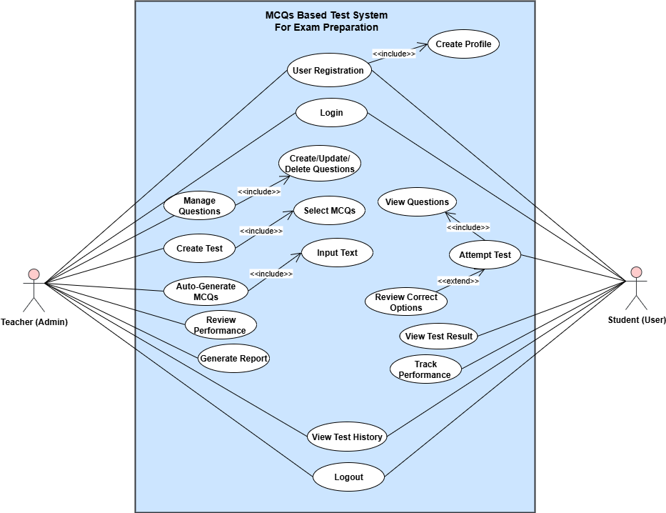
Figure 1.0: Use Case Diagram

Usage Scenarios

Below is a table providing the usage scenarios for the key use cases in MCQ-Based Test System.

Usage Scenario 1:

Use Case Title | User Registration
Use Case Id | UC001
Actions | Users fills the registration form, submits details, and receives confirmation.
Description | Enable teachers and students to register for the system by creating accounts.
Alternate Paths | The system prompts the user to correct invalid details.
Pre-Conditions | User accesses the registration page.
Post-Conditions | User account is created and activated.
Author | Bc230209941
Exceptions | Registration fails due to network or database issues.

Usage Scenario 2:

Use Case Title | Login
Use Case Id | UC002
Actions | User enters credentials (username and password) and logs in.
Description | Authenticates teachers and students to access their respective functionalities.
Alternate Paths | System allows password reset if credentials are invalid.
Pre-Conditions | User must have a registered account.
Post-Conditions | User is logged in and redirected to the dashboard.
Author | Bc230209941
Exceptions | Incorrect credentials or server downtime prevents login.

Usage Scenario 3:

Use Case Title | Create Question Bank
Use Case Id | UC003
Actions | Teacher adds questions, categorizes them by topics, difficulty levels, and formats (e.g., multiple-choice, true/false).
Description | Allows teachers to create and manage a question bank for use in tests.
Alternate Paths | Teacher edits or deletes questions later.
Pre-Conditions | Teacher is logged in and accesses question bank module.
Post-Conditions | Questions are saved in the question bank.
Author | Bc230209941
Exceptions | Question data entry fails due to invalid input or storage issues.

Usage Scenario 4:

Use Case Title | Generate Test by Teacher
Use Case Id | UC004
Actions | Teacher selects questions from the question bank or uses auto-MCQ generation and sets parameters such as time limit and difficulty level.
Description | Teachers can design customized tests for students using pre-existing or auto-generated questions.
Alternate Paths | Teacher skips optional test parameters and uses defaults.
Pre-Conditions | Teacher is logged in and accesses the test module.
Post-Conditions | Test is saved and ready for students.
Author | Bc230209941
Exceptions | Test creation fails due to insufficient questions or NLP service failure for auto-MCQ generation.

Usage Scenario 5:

Use Case Title | Auto-Generate MCQs
Use Case Id | UC005
Actions | Teacher inputs text, and the system generates MCQs.
Description | Uses NLP to auto-generate multiple-choice questions based on input.
Alternate Paths | Teacher reviews and edits the auto-generated MCQs.
Pre-Conditions | Valid input text must be provided.
Post-Conditions | MCQs are generated and added to the question bank.
Author | Bc230209941
Exceptions | Invalid input or NLP system error.

Usage Scenario 6:

Use Case Title | Attempt Test
Use Case Id | UC006
Actions | Student selects a test and answers questions.
Description | Students attempt a test created by the teacher and submit answers for evaluation.
Alternate Paths | Save test progress automatically if a student disconnects or pauses the test.
Pre-Conditions | A test must be available for the student.
Post-Conditions | Test is completed, and results are recorded.
Author | Bc230209941
Exceptions | Timeout or submission error.

Usage Scenario 7:

Use Case Title | View Test Result
Use Case Id | UC007
Actions | Student views their test results with details of correct/incorrect answers.
Description | Provides feedback and detailed test results to students.
Alternate Paths | Allow students to export results to PDF for offline viewing.
Pre-Conditions | Student must have completed and submitted a test.
Post-Conditions | Test results are displayed successfully.
Author | Bc230209941
Exceptions | Results are unavailable due to system error.

Usage Scenario 8:

Use Case Title | View Test History
Use Case Id | UC008
Actions | Student and Teacher views logs of all previously taken tests.
Description | Student and Teacher views logs of all previously taken tests.
Alternate Paths | Enable filtering test history by date or subject for quick access.
Pre-Conditions | Student must have taken at least one test. And Teacher must have given at least one test.
Post-Conditions | Test history is displayed successfully.
Author | Bc230209941
Exceptions | Data retrieval error or incomplete history.

Usage Scenario 9:

Use Case Title | Review Performance
Use Case Id | UC009
Actions | Student analyzes overall performance, including strengths and weaknesses.
Description | Displays performance trends and insights for self-evaluation.
Alternate Paths | Students ignore detailed analytics and only review scores.
Pre-Conditions | Performance data must be available.
Post-Conditions | Performance trends and insights are displayed.
Author | Bc230209941
Exceptions | Insufficient data for meaningful analysis.

Usage Scenario 10:

Use Case Title | Generate Report
Use Case Id | UC0010
Actions | Teacher generates a summary report of test results for all students.
Description | Helps teachers track overall class performance and individual student progress.
Alternate Paths | Export report in different formats (e.g., PDF, Excel).
Pre-Conditions | Tests must have been conducted by students.
Post-Conditions | Report is generated and saved.
Author | Bc230209941
Exceptions | System error or no data available for the report.

Usage Scenario 11:

Use Case Title | Track Performance
Use Case Id | UC0011
Actions | Student views their progress charts and detailed analytics.
Description | Displays personalized performance tracking for students and class-wise performance for teachers.
Alternate Paths | Ignore detailed analytics and only review scores.
Pre-Conditions | Performance data must exist.
Post-Conditions | Analytics and progress reports are displayed.
Author | Bc230209941
Exceptions | Data retrieval or analytics error.

Usage Scenario 12:

Use Case Title | Logout
Use Case Id | UC0012
Actions | User logs out to end the session.
Description | Terminates the user session safely and securely.
Alternate Paths | Automatically log the user out after a set period of inactivity.
Pre-Conditions | User must be logged in.
Post-Conditions | Session is terminated successfully.
Author | Bc230209941
Exceptions | Logout process fails due to system error.

“Adopted Methodology”

For this project, the VU Process Model is adopted as the development methodology. This is a hybrid model used primarily in Virtual University projects. It combines elements of the Waterfall model (a linear, sequential approach) with the Spiral model (an iterative, risk-driven approach).
The VU Process Model places a strong emphasis on adaptability and permits going back to earlier stages in response to input and changing project needs.

It consists of two Models:
- Waterfall model
- Spiral Model

Phases of VU Process Model Applied to the Project:

- Requirements Gathering (SRS Phase)
  - Define functional and non-functional requirements.
  - Identify user roles, use cases, and system modules.

- Design Phase
  - Create architectural and component-level designs.
  - Develop use case and sequence diagrams.

- Development Phase
  - Implement the system modules iteratively with Django for the backend and a responsive front-end framework.
  - Integrate Natural Language Processing (NLP) for MCQ generation.

- Testing Phase
  - Perform unit testing, integration testing, and system testing to ensure functionality and reliability.
  - Test edge cases and analyze performance.

- Deployment Phase
  - Deploy the system on a web server.
  - Ensure the system is scalable, secure, and accessible.

- Risk Analysis and Iteration (Spiral Aspect)
  - At the end of each phase, evaluate risks such as system performance, scalability, or user experience.
  - Make iterative improvements based on feedback.
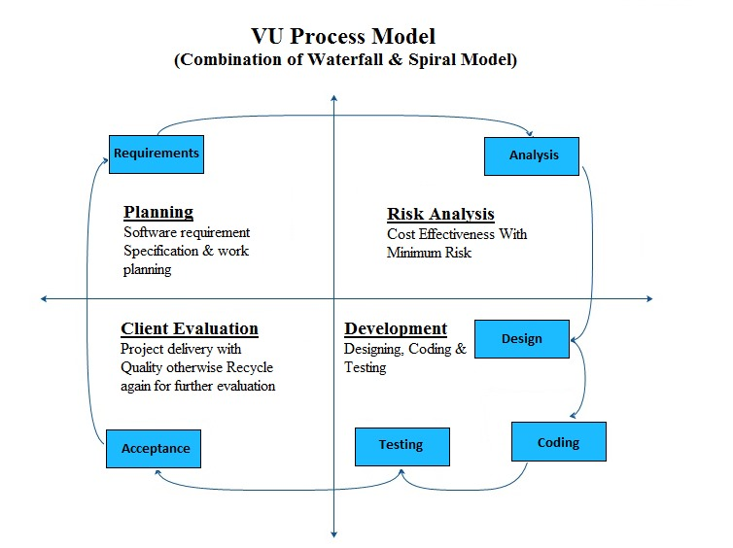
Figure 2.0: VU process Model

Waterfall Model

This model is also known as linear sequential model. The principal stages of the model map directly onto fundamental development activities. It suggests a systematic, sequential approach to software development that begins at the system level and progresses through the analysis, design, coding, testing, and maintenance.

Phases of the Waterfall Model:

Each cycle includes following phases:

- Requirements: Gather and document all project requirements.
- Design: Plan the system architecture and design.
- Implementation: Write and integrate the code.
- Testing: Test the system to find and fix defects.
- Deployment: Deliver the finished product to the client.
- Maintenance: Handle updates, fixes, and improvements.

However, it’s less flexible, making it less suitable for projects with changing requirements.
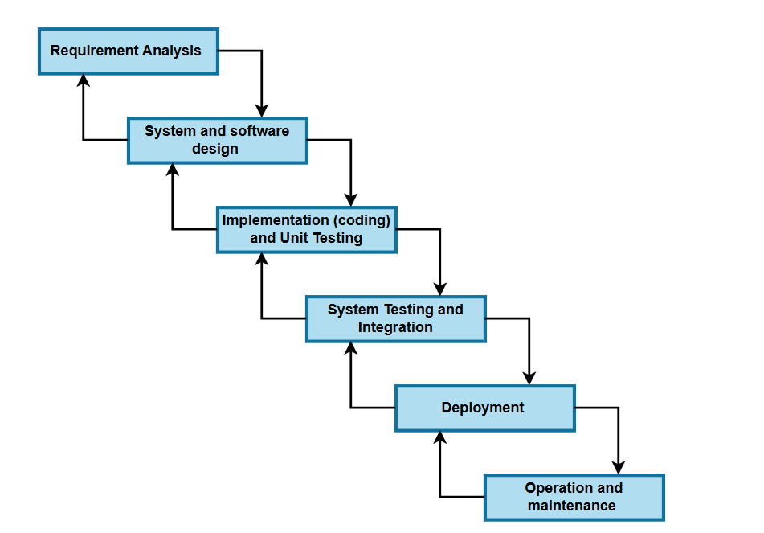

Figure 3.1 Waterfall Model

Spiral Model

The Spiral Model is a software development approach that combines elements of Waterfall and Iterative models. It focuses on managing risks and involves repeating development phases in cycles.

Phases of the Spiral Model:

Each cycle includes four phases:

- Planning: Define goals, requirements, and constraints.
- Risk Analysis: Identify and analyze potential risks in the project.
- Development: Develop and refine the system.
- Evaluation: Review progress, get feedback, and adjust the plan.

After each cycle, the project is reassessed, and new iterations are planned based on feedback, allowing for continuous refinement and adjustment.
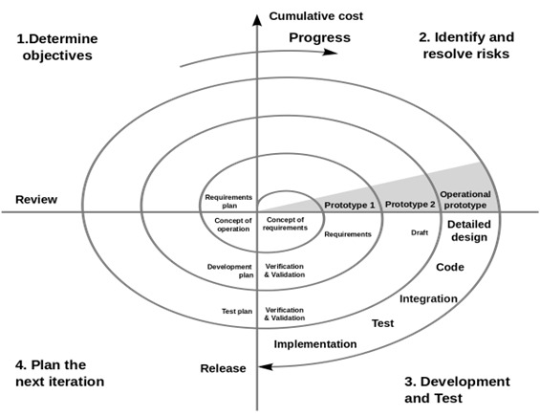

Figure 4.1 Spiral Model

Work Plan

The work plan for this project is structured into four distinct phases: SRS Document, Design Document, Prototype Phase, and Final Deliverable. Every phase includes a number of crucial duties that guarantee the project moves forward methodically and effectively.

Gantt Chart:

The Gantt chart provides a visual representation of the project timeline, indicating task durations and overlaps. Below is a gantt chart og this project:
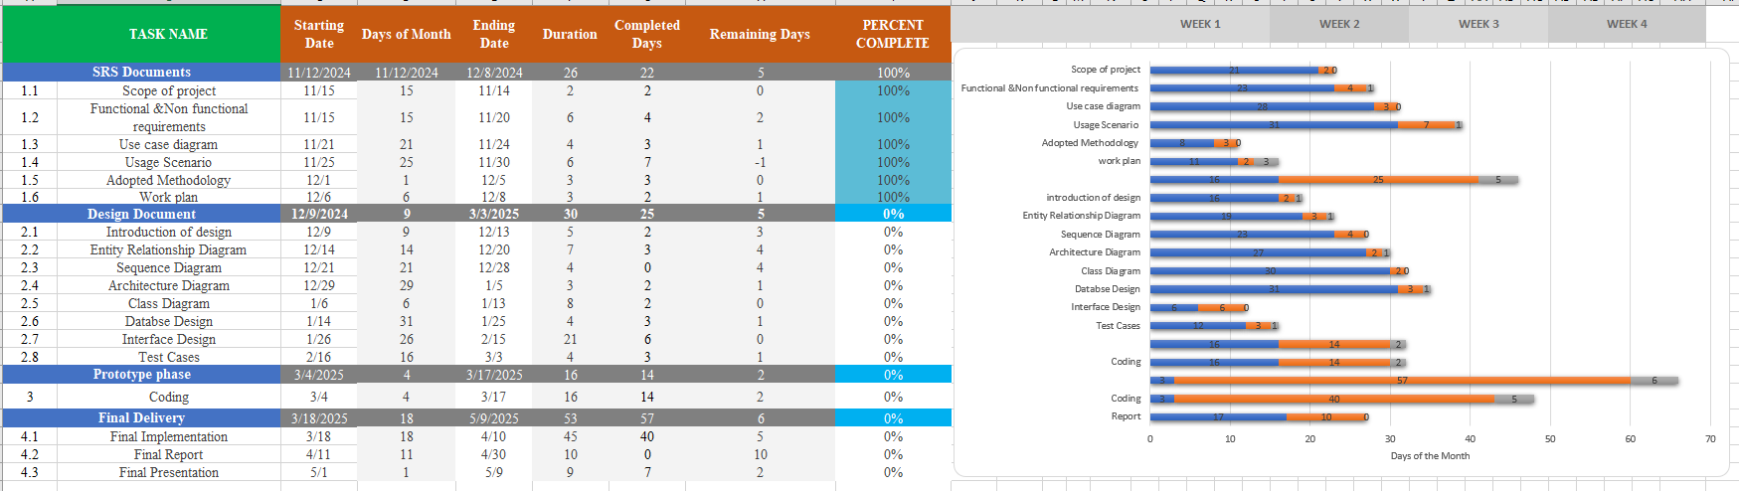

Figure 4.1 Gantt Chart

Chapter No 2

Design Documentation

“Introduction to Design Documentation”

Introduction of Design Phase:

The Design Phase plays a crucial role in the software development life cycle, translating the Software Requirement Specification (SRS) into a structured blueprint for implementation. This phase of the MCQ-Based Test System for Exam Preparation focuses on defining the system's components, their interactions, and the overall design to ensure a robust, scalable, and user-friendly application.

Purpose of Design Phase:

Its primary purpose is to transform the requirements gathered during the Analysis phase into a detailed, structured, and formal design of the software system. Here are the key objectives of the Design phase:

- Defines system architecture, interactions, and data flow.
- Alters functional requirements into a structured system design.
- Ensures the scalability, efficiency, and security of the system.
- Helps in the early detection of design defects, lowering the development risks.

Aspects of Design Phase:

- Entity Relationship Diagram (ERD):

- Establishes the relationships between entities, illustrating how different data points interact and relate to one another.
- Defines the database structure, specifying how data is organized and stored within the system.

- Sequence Diagrams:

- It depicts the sequence of interactions between system components.
- It illustrates the chronological flow of events, effectively demonstrating the dynamic behavior of the system.

- Architecture Design Diagram:

- Outlines the system's high-level structure, including components, modules and their interactions.
- Visualizes the system layout, ensuring efficient and effective component collaboration.

- Class Diagram:

- Defines the structure of the system by showing classes, their attributes and methods, following OOP principles.
- Helps in understanding the relationships and interactions between different classes, promoting encapsulation, inheritance and polymorphism.

- Database Design:

- Involves structuring and organizing data within a database, ensuring data integrity and efficiency.
- It defines tables, relationships and constraints, supporting effective data storage and retrieval.

- Interface Design:

- Includes the graphical user interface (GUI) wireframes/screenshots.
- Focuses on creating user-friendly and visually appealing interfaces that enhance user experience.
- Designs layouts, interactions, and navigation to ensure ease of use and accessibility.

- Test Cases:

- Defines test cases for different system functionalities to ensure reliability.
- Outline the specific conditions and expected outcomes to validate system functionality.
- Ensure that the system meets requirements and performs as intended under various scenarios.

By following this structured design approach, the development team can build a robust MCQ-based test system, ensuring efficient performance, usability, and security.

Importance of Design Documentation:
Design documentation plays a crucial role in the software development process. Some of the Important key points are given below:

- Clear Understanding of System Architecture: Ensures that all stakeholders have a well-defined view of the system's structure and components.
- Enhanced Communication: Acts as a reference guide, improving collaboration among developers, designers, and stakeholders.
- Consistency Throughout Development: Maintains uniformity in design principles, reducing conflicts during implementation.
- Early Identification of Challenges: Helps detect potential issues at an early stage, minimizing costly revisions later.
- Improved Development Efficiency: Reduces misunderstandings and speeds up the development process by providing clear guidelines.
- Streamlined Collaboration: Facilitates teamwork by ensuring everyone follows a standardized approach.
- Simplifies Future Modifications: Well-structured documentation makes it easier to update, maintain, and scale the system.
- Supports Testing and Debugging: Provides testers with a structured framework for validating system functionalities.
- Ensures Robust and Scalable System: Leads to a more reliable and adaptable software solution.
- Serves as a Training Resource: Helps onboard new team members quickly by offering a detailed understanding of the system.

Entity Relationship Diagram

The Entity-Relationship Diagram (ERD) of the MCQ-Based Test System represents the structure of the database and its relationships.

It provides:
- Entities: Key entities include Users, Questions, Tests, Results, and Performance Tracking.
- Relationships: Defines how entities interact, such as students attempting tests, teachers creating questions, and the system storing results.
- Attributes: Each entity has specific attributes like User ID, Question Text, Test Score, and Timestamp to store relevant information.
- Normalization Considerations: Ensures that the database structure is optimized, reducing redundancy and improving efficiency.

This diagram helps in understanding how data flows between different modules, ensuring smooth system functionality.

ER Diagram:

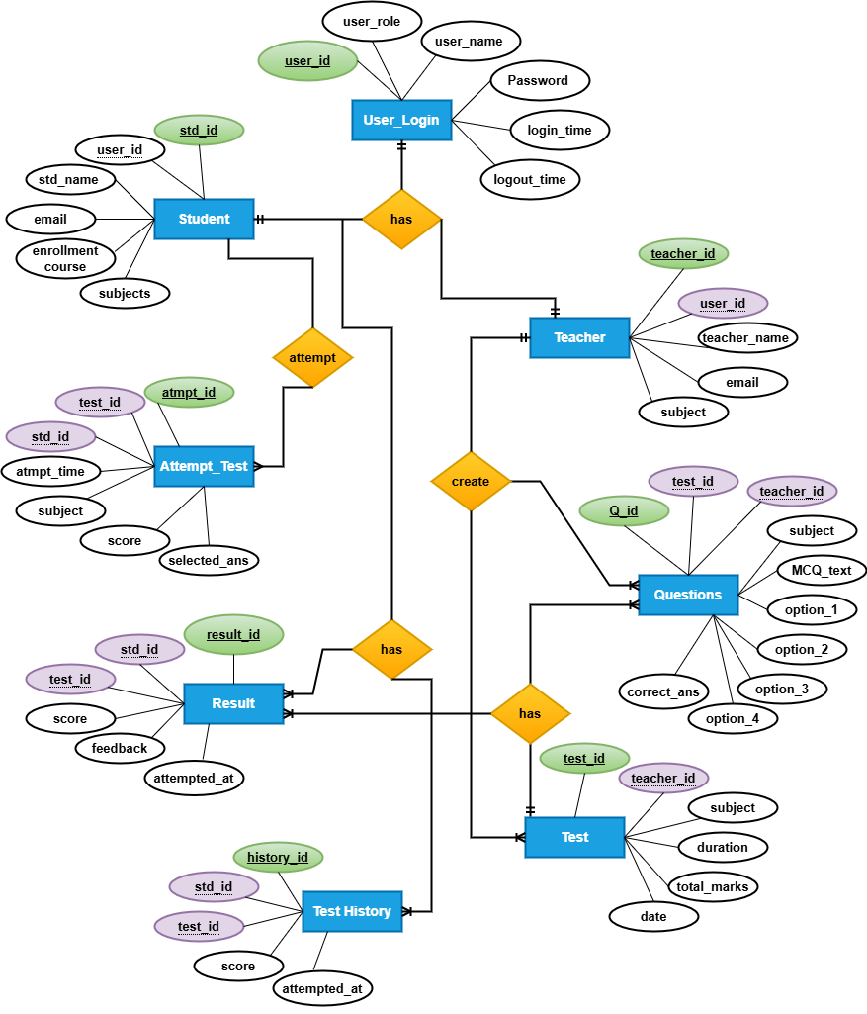

Figure 1.0: ERD

Sequence Diagram

The Sequence Diagram of the MCQ-Based Test System visually represents the interactions between different system components (teacher, student, database etc.) over time. The dynamic flow of procedures such as test development, MCQ production, and test attempts is better understood with the aid of these diagrams.

It provides:
- Actors & Components: Key actors include Students, Teachers and the System, interacting with modules like Authentication, Test Management, and Result Processing.
- Message Flow: Shows step-by-step communication, such as students logging in, attempting tests, and receiving results, while teachers create and manage questions.
- Lifelines & Events: Illustrates the sequence of actions with timestamps, ensuring a clear flow of operations from initiation to completion.
- Error Handling: Highlights alternate flows for scenarios like incorrect login attempts or test submission failures.

This diagram helps in understanding the system’s real-time behavior, ensuring smooth and efficient interaction between different components.

User Authentication:

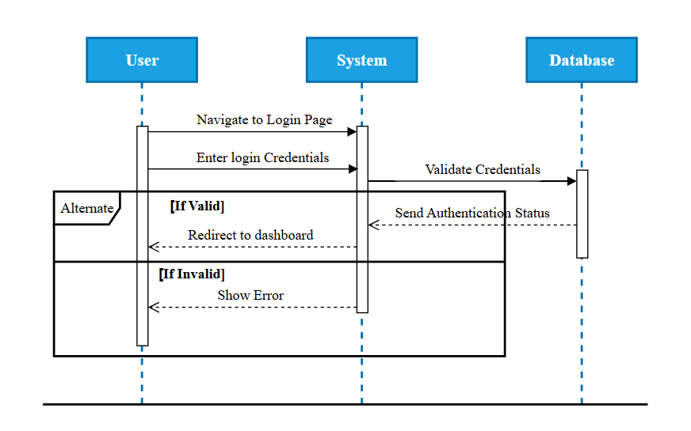
Figure 2.0: User Authentication Sequence Diagram

Manage MCQs (Teacher):
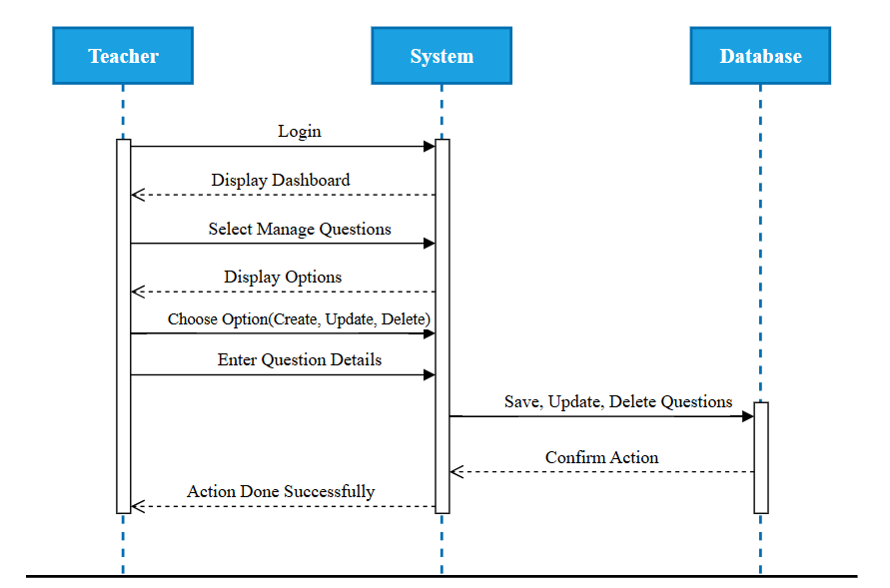
Figure 2.2: Teacher Manages MCQs Sequence Diagram

Test Creation (Teacher):
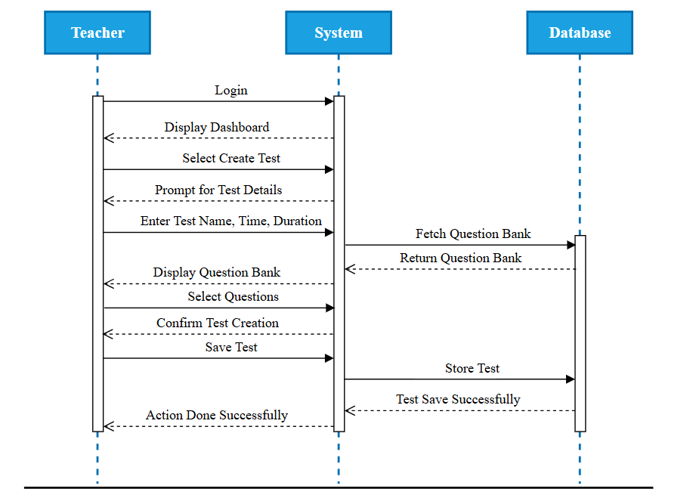
Figure 2.3: Test Created by Teacher Sequence Diagram

Attempt Test (Student):
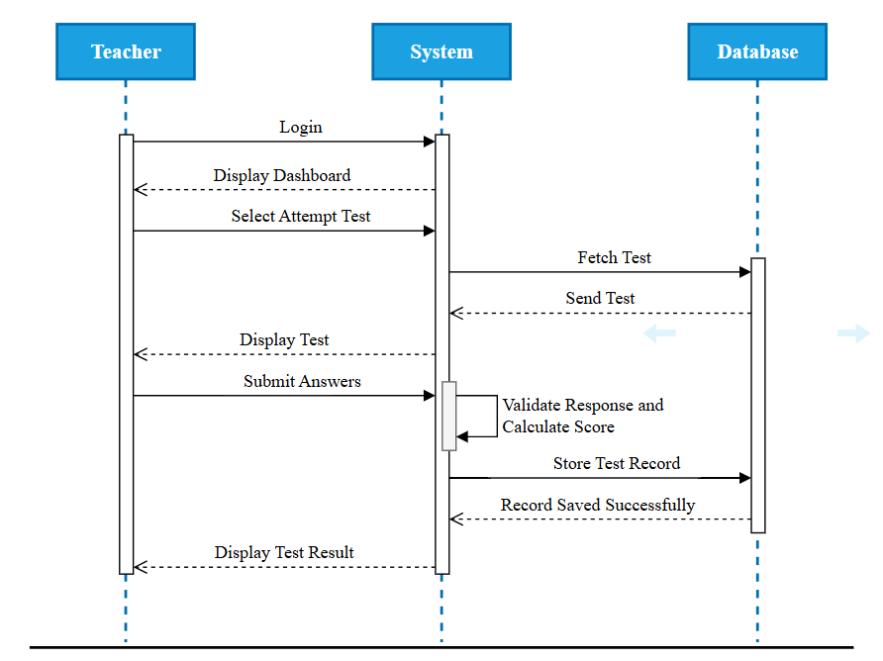
Figure 2.4: Student Attempting Test Sequence Diagram

Automatic MCQ Generation (NLP):
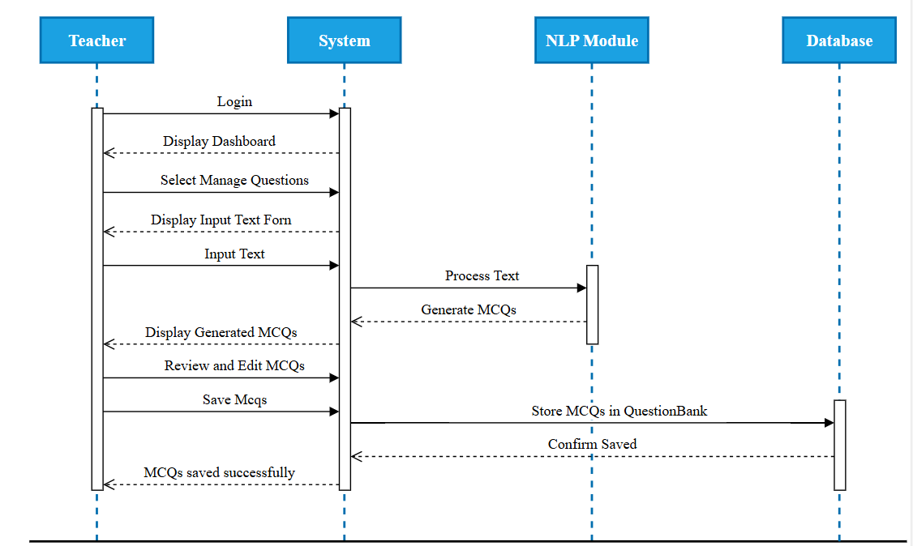
Figure 2.5: Auto MCQs Generation (NLP) Sequence Diagram

View History:
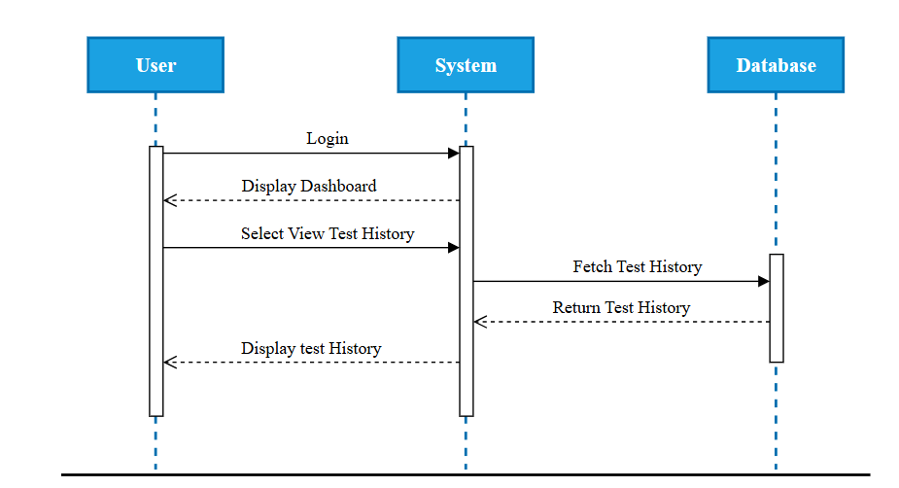
Figure 2.6: View History Sequence Diagram

Logout:
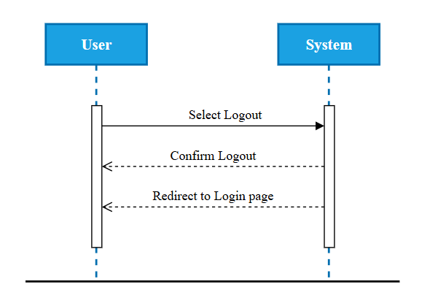
Figure 2.7: Logout Sequence Diagram

Overall System Sequence Diagram:

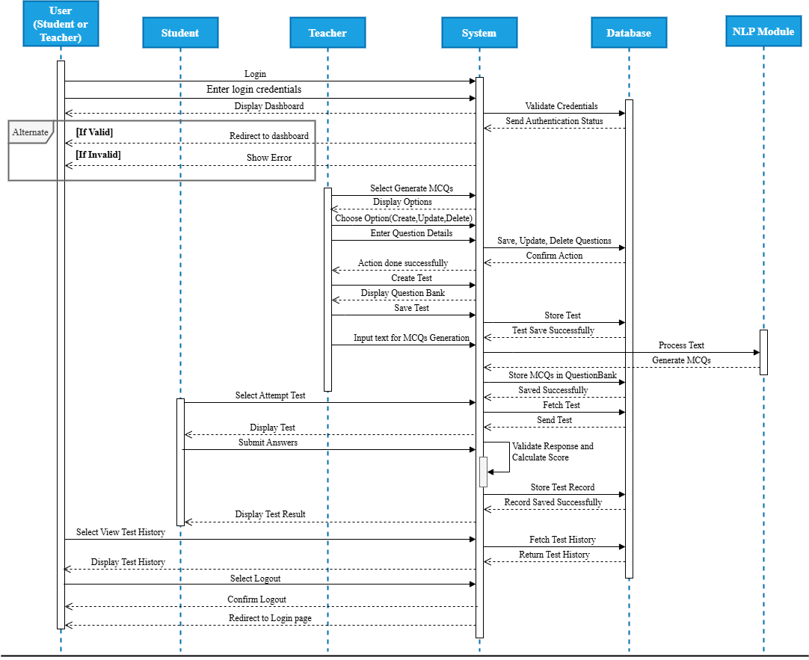
Figure 2.3: Sequence Diagram of MCQs Based Test System

Architecture Design Diagram

The high-level structure of the MCQ-Based Test System is described in the Architecture Design Diagram.
It offers:
- Components: Important parts include the database, web server, and NLP service.
- Interactions: How these parts work together to complete tasks like creating and assessing tests.
- Data Flow: The movement of information between the system backend, students, and teachers.
- Scalability Taking into account: Making sure the system can support numerous users at once.

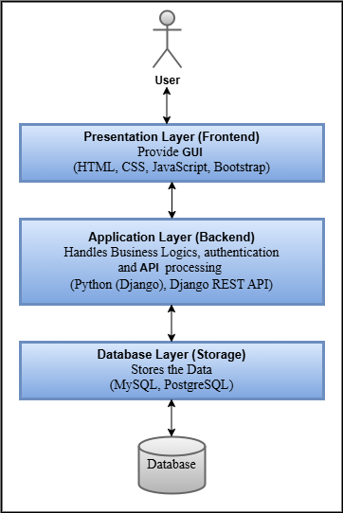
Figure 3.0: Architecture Design Diagram

Class Diagram

The Class Diagram represents the object-oriented structure of the MCQ-Based Test System by defining its key classes, attributes, and relationships.
It offers:
- Core Classes: Essential entities like User, Student, Teacher, TestAttempt, Result class and Question class.
- Relationships: The associations between classes, such as Student taking a Test and Teacher managing a Question Bank etc.
- Methods & Attributes: Defines attributes (e.g., email, password, subject) and methods (e.g., createTest(), calculateResult()).
- Data Flow: How information moves between objects, such as a Test fetching questions from the Question Bank.
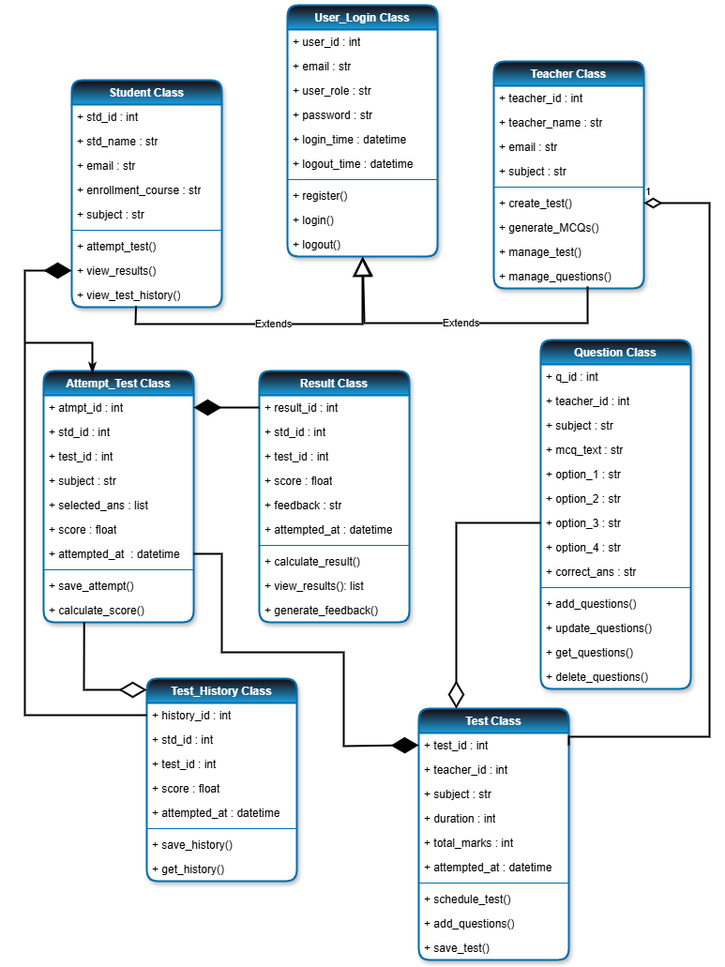

Figure 4.0: Class Diagram

Database Design

The Database Design of the MCQ-Based Test System defines structured data storage, ensuring efficient retrieval and management of users, questions, tests, and results. It includes key entities like Users, Questions, Tests, AttemptTest, and TestHistory, with relationships maintaining data integrity and supporting system functionality.
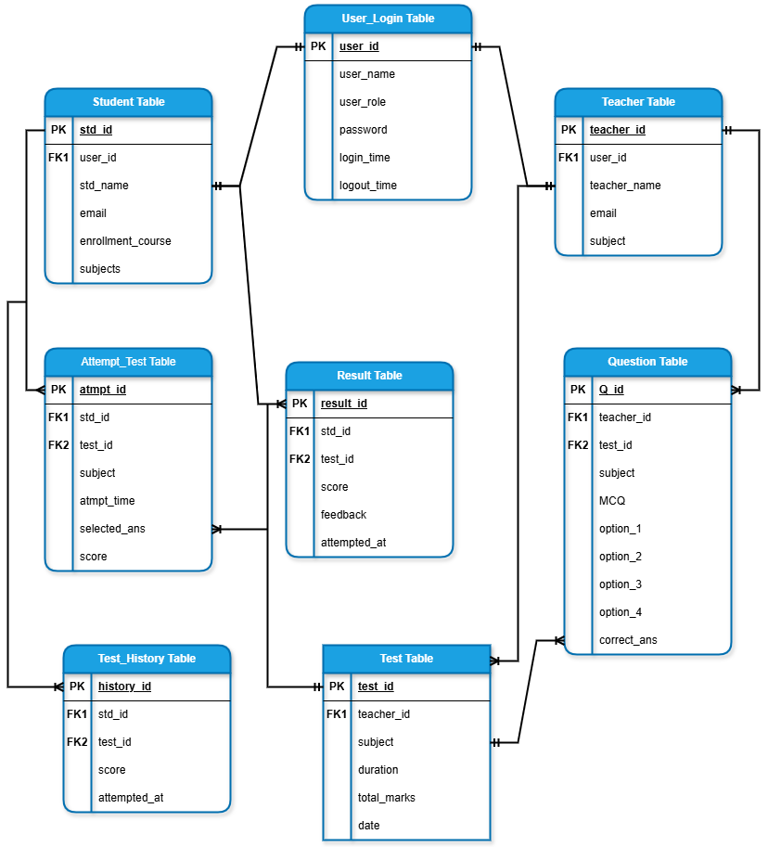

Figure 5.0: Database Design Diagram

Interface Design

The user interface of the MCQ-Based Test System is designed for a seamless and interactive user experience.
It offers:
- User Roles: Separate interfaces for Teachers (Admins) and Students (End Users).
- Navigation: A user-friendly dashboard for accessing key features like test creation, question bank management, and performance tracking.
- Interactivity: Real-time feedback on test attempts, dynamic test generation, and instant evaluation.
- Responsiveness: Ensures accessibility across multiple devices with a clean and modern UI.

Registration:

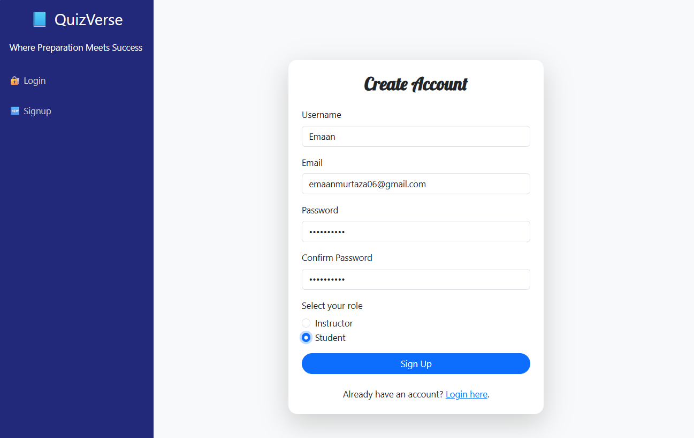

Figure 6.0: Registration Interface

Login Interface:

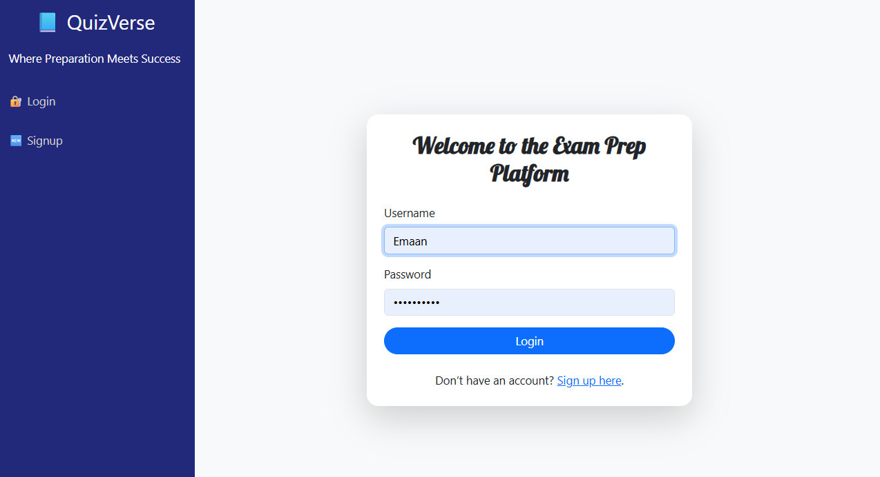

Figure 6.1: Login Interface

MCQs Creation Interface:

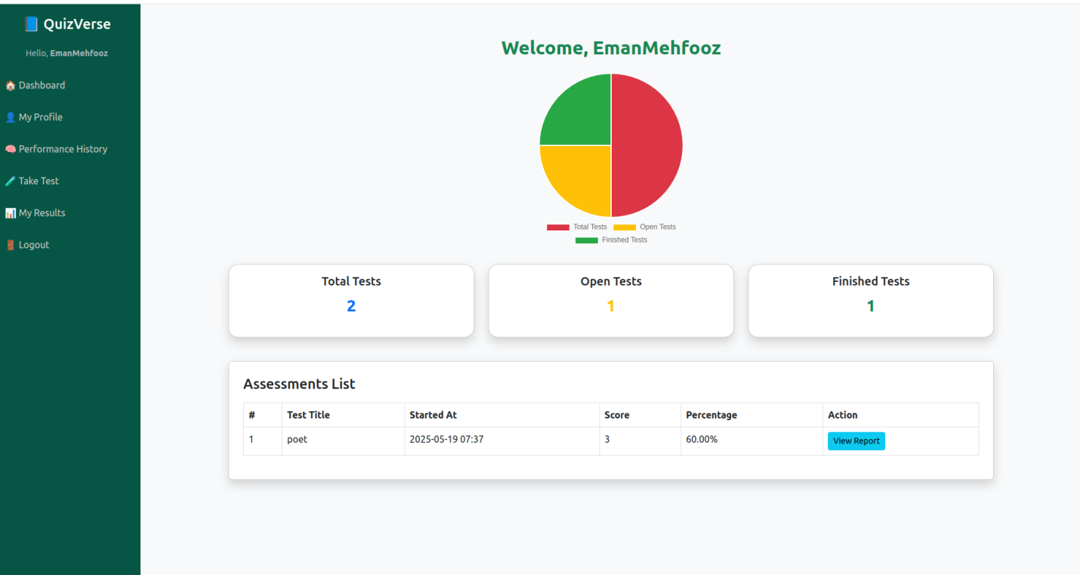
Figure 6.2: MCQs Creation Interface

Student Starting Test Interface:

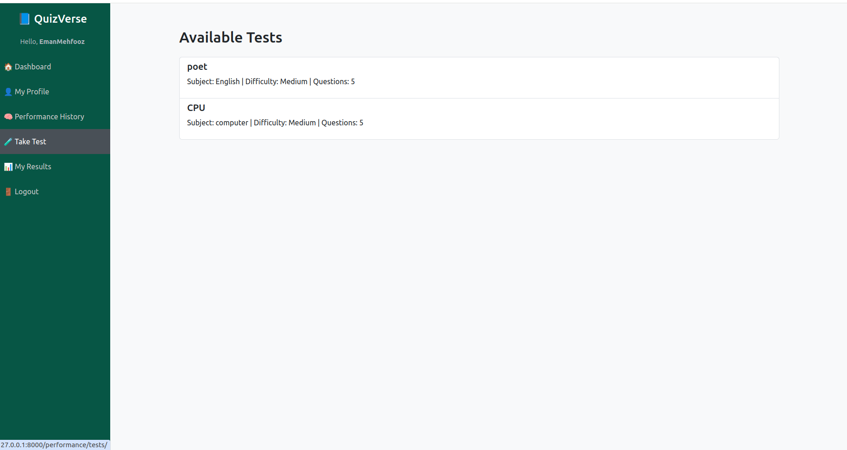

Figure 6.3: Student Starting Test Interface

Student Attempting Test Interface:

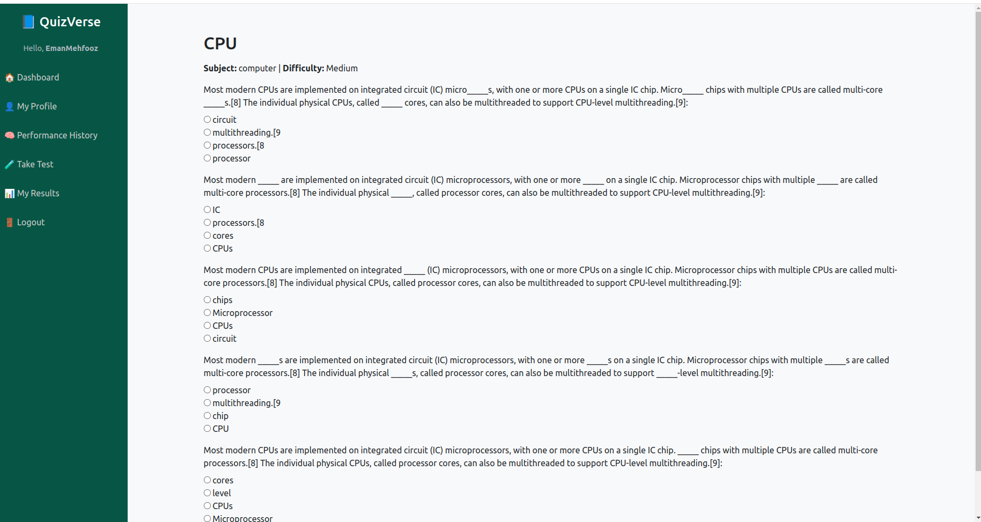

Figure 6.3: Student Attempting Test Interface

Result Interface:

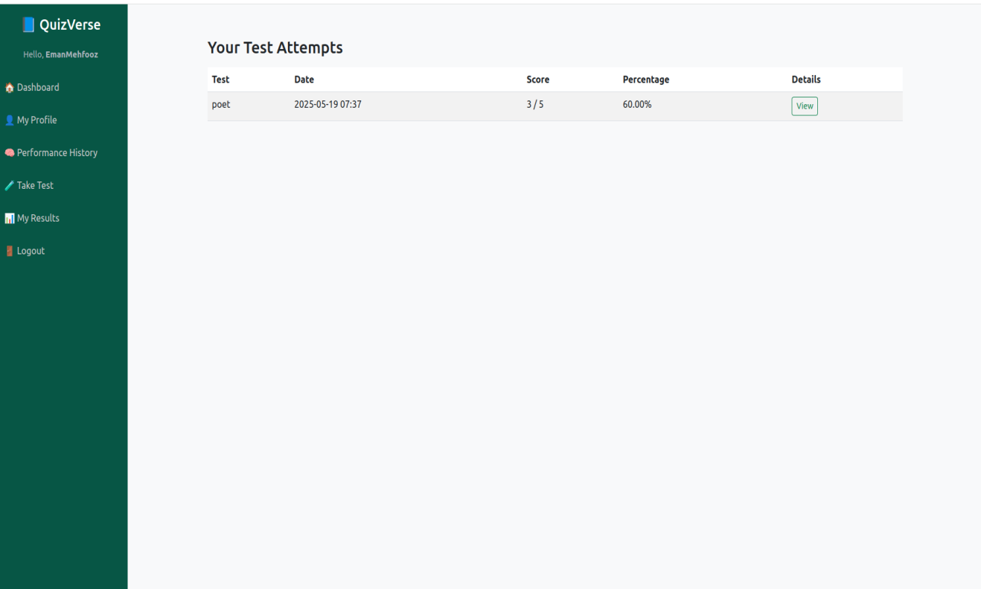
Figure 6.4: Student Starting Test Interface

View History Interface:

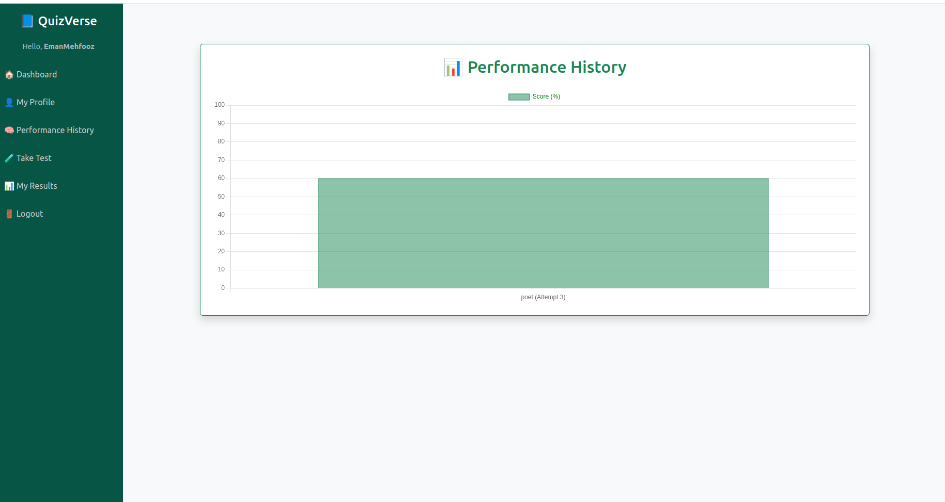
Figure 6.2: View History Interface

Test Cases

The test cases in this area are intended to confirm the system's usability, performance, and functionality.

It consists of:
- Functional tests: Verifying functions such as automatic MCQ generation, test creation, and login.
- Performance checks: Verifying that the system functions well when it is heavily used (for example, when several students are taking tests).
- Usability tests: Verifying that both teachers and students can easily navigate the UI.

Test Case 1:

Test Case Title | User Registration
Test Case Id | TC001
Description | Ensures that new users (students/teachers) can successfully register by providing valid details. The system should validate input and store credentials securely.
Pre-Conditions | User is not registered.
Test Steps | - Open registration page.  - Enter valid details.  - Submit the form.
Expected Result | User account is created successfully, and confirmation email is sent.
Actual Result | Account created successfully; confirmation email received.
Status | Pass
Tested By | Bc230209941
Exceptions | Weak password or existing email prevents registration.

Test Case 2:

Test Case Title | Login with valid credentials
Test Case Id | TC002
Description | Verifies that registered users can log in with correct credentials and are redirected to their dashboard.
Pre-Conditions | User is registered.
Test Steps | - Open login page.  - Enter correct email & password.  - Click login button.
Expected Result | User is redirected to dashboard
Actual Result | User Successfully logged in and redirected to dashboard.
Status | Pass
Tested By | Bc230209941
Exceptions | Server downtime or incorrect credentials prevent login.

Test Case 3:

Test Case Title | Login with invalid credentials
Test Case Id | TC003
Description | Checks that an error message is displayed when incorrect credentials are entered, preventing unauthorized access.
Pre-Conditions | User is registered.
Test Steps | - Open login page.  - Enter incorrect credentials.  - Click login.
Expected Result | Error message displayed.
Actual Result | Error message displayed: “Invalid username or password”
Status | Pass
Tested By | Bc230209941
Exceptions | System may not show an error message properly

Test Case 4:

Test Case Title | Logout
Test Case Id | TC004
Description | Ensures that users can securely log out and are redirected to the login page.
Pre-Conditions | User is logged in.
Test Steps | Click logout button.
Expected Result | User is redirected to login page.
Actual Result | User successfully logged out and redirected to login.
Status | Pass
Tested By | Bc230209941
Exceptions | If session does not expire, user remains logged in.

Test Case 5:

Test Case Title | Add MCQ
Test Case Id | TC005
Description | Ensures that teachers can add new MCQs to the question bank with proper validation and confirmation.
Pre-Conditions | Teacher is logged in.
Test Steps | - Go to Question Bank.  - Click ‘Add Question’.  - Enter question details.  - Click Save.
Expected Result | Question is added successfully, and confirmation message is shown.
Actual Result | MCQ added successfully, confirmation displayed.
Status | Pass
Tested By | Bc230209941
Exceptions | If fields are empty, question cannot be saved.

Test Case 6:

Test Case Title | Edit MCQ
Test Case Id | TC006
Description | Ensures that teachers can update an existing MCQ and save changes.
Pre-Conditions | Teacher is logged in.
Test Steps | - Go to Question Bank.  - Select a question.  - Click Edit.  - Modify details.  - Click Save.
Expected Result | Changes are saved successfully, and message displayed.
Actual Result | Question edited successfully; changes reflected.
Status | Pass
Tested By | Bc230209941
Exceptions | If database update fails, changes are not saved.

Test Case 7:

Test Case Title | Delete MCQ
Test Case Id | TC007
Description | Ensures that teachers can remove an MCQ permanently from the question bank.
Pre-Conditions | Teacher is logged in.
Test Steps | - Go to Question Bank.  - Select a question.  - Click Delete.  - Confirm deletion.
Expected Result | Question is removed Successfully.
Actual Result | MCQ deleted successfully.
Status | Pass
Tested By | Bc230209941
Exceptions | System may not delete questions linked to tests.

Test Case 8:

Test Case Title | Create Test
Test Case Id | TC008
Description | Ensures that teachers can create a test by selecting questions and setting difficulty levels.
Pre-Conditions | Teacher is logged in.
Test Steps | - Click ‘Create Test’.  - Select questions.  - Set difficulty level & time limit.  - Click Save.
Expected Result | Test is created successfully, and confirmation message displayed.
Actual Result | Test created successfully.
Status | Pass
Tested By | Bc230209941
Exceptions | Test cannot be created if no questions are selected.

Test Case 9:

Test Case Title | Edit Test
Test Case Id | TC009
Description | Ensures that teachers can modify test details before it is published.
Pre-Conditions | Teacher is logged in.
Test Steps | - Go to Test Management.  - Select a test.  - Click Edit.  - Modify details.  - Click Save.
Expected Result | Changes are saved successfully.
Actual Result | Teste edited successfully.
Status | Pass
Tested By | Bc230209941
Exceptions | System may not allow changes if test is already attempted.

Test Case 10:

Test Case Title | Delete Test
Test Case Id | TC010
Description | Ensures that teachers can remove a test before it is taken by students.
Pre-Conditions | Teacher is logged in.
Test Steps | - Go to Test Management.  - Select a test.  - Click Delete.  - Confirm Deletion.
Expected Result | Test is deleted successfully.
Actual Result | Test deleted successfully.
Status | Pass
Tested By | Bc230209941
Exceptions | System may prevent deletion if test has results.

Test Case 11:

Test Case Title | Attempted Test
Test Case Id | TC011
Description | Ensures that students can attempt a test by answering MCQs and submitting responses.
Pre-Conditions | Student is Logged in.
Test Steps | - Select a test.  - Start answering MCQs.  - Click Submit.
Expected Result | Test is submitted successfully, and confirmation displayed.
Actual Result | Test submitted successfully.
Status | Pass
Tested By | Bc230209941
Exceptions | If internet disconnects, submission fails.

Test Case 12:

Test Case Title | Auto-Evaluations
Test Case Id | TC012
Description | Verifies that the system auto-evaluates a test and generates results instantly.
Pre-Conditions | Test is submitted.
Test Steps | - System evaluates the test.  - Generates results instantly.
Expected Result | Student receives score and feedback.
Actual Result | Result displayed Instantly.
Status | Pass
Tested By | Bc230209941
Exceptions | If evaluation service fails, results are delayed.

Test Case 13:

Test Case Title | Timer
Test Case Id | TC013
Description | Ensures that the test auto-submits when the countdown timer reaches zero.
Pre-Conditions | Student is taking a test.
Test Steps | - Start Test.  - Wait until timer runs out.
Expected Result | Test auto-submits when time is over.
Actual Result | Test auto-submitted at the end of the timer.
Status | Pass
Tested By | Bc230209941
Exceptions | Timer may not function properly.

Test Case 14:

Test Case Title | View Test History
Test Case Id | TC014
Description | Ensures that students can view past test attempts and scores.
Pre-Conditions | Student is logged in.
Test Steps | - Click on ‘Test History’.  - View past test results.
Expected Result | Student sees test performance details.
Actual Result | Test history displayed correctly.
Status | Pass
Tested By | Bc230209941
Exceptions | If history does not load, results may be missing.

Test Case 15:

Test Case Title | Performance Analytics
Test Case Id | TC015
Description | Ensures that students can view graphical representation of their performance trends.
Pre-Conditions | Student is logged in.
Test Steps | - Click ‘Performance Analytics’.  - View graphical representation.
Expected Result | Performance trends displayed.
Actual Result | Graphical analytics displayed correctly.
Status | Pass
Tested By | Bc230209941
Exceptions | If analytics API fails, no data is shown.

Test Case 16:

Test Case Title | Automatic MCQs generation
Test Case Id | TC016
Description | Ensures the NLP model generates relevant MCQs from input text with correct options.
Pre-Conditions | Teacher is logged in.
Test Steps | - Go to MCQ Generator.  - Input a paragraph.  - Click 'Generate'.
Expected Result | AI-generated MCQs are displayed.
Actual Result | MCQs generated successfully.
Status | Pass
Tested By | Bc230209941
Exceptions | If NLP engine fails, no MCQs are generated or irrelevant results appear.

Test Case 17:

Test Case Title | Automatic Review & Edit MCQs
Test Case Id | TC017
Description | Ensures teachers can edit and save AI-generated MCQs.
Pre-Conditions | Teacher is logged in.
Test Steps | - Review generated MCQs.  - Edit as needed.  - Save changes.
Expected Result | MCQs are finalized and saved.
Actual Result | Teacher edited and saved MCQs successfully.
Status | Pass
Tested By | Bc230209941
Exceptions | If database update fails, MCQs may not be saved.

Chapter No 3

Development Phase

“Tools And Technologies”

The development of this project involved a combination of modern web development tools, natural language processing libraries, and data handling utilities. The following technologies were integral to the implementation and functionality of the system:

- Backend Framework

Django 5.2:
Django is a high-level Python web framework that facilitates rapid development and clean, pragmatic design. It was used to manage server-side logic, URL routing, database models, forms, and templating. Django’s built-in admin panel also allowed for efficient content and user management.

- Templating Engine

Django Templates:
Django’s built-in templating engine was utilized to render dynamic HTML pages on the frontend using server-side data.

Jinja2:
Jinja2, a fast and secure templating engine for Python, complements Django’s rendering system and enhances the ability to write reusable, readable templates.

- Natural Language Processing (NLP)

spaCy 3.8.5:
spaCy is an advanced NLP library used for linguistic analysis, including tokenization, named entity recognition (NER), part-of-speech tagging, and syntactic parsing. It enabled the project to process and extract meaningful information from textual data.

en_core_web_sm:
This is spaCy’s small English language model, which provides linguistic annotations required for NLP tasks.

- NLP Supporting Libraries

srsly, thinc, cymem, murmurhash, preshed, wasabi, confection, spacy-loggers, spacy-legacy:
These are essential dependencies of spaCy that enable efficient computation, serialization, logging, and model execution. They ensure high performance and modular architecture of the NLP components.

- Text Preprocessing

nltk 3.9.1:
The Natural Language Toolkit (NLTK) was employed for additional text preprocessing tasks such as tokenization, stop word removal, and stemming where required.

- Scientific Computing and Model Serialization

NumPy 2.2.5:
NumPy was used to support numerical operations within NLP workflows and data processing components.

joblib 1.5.0:
Joblib facilitated the serialization and deserialization of NLP models and preprocessing pipelines, enabling efficient model loading and saving.

- Data Validation and Type Management

Pydantic 2.11.4:
Pydantic provided data validation using Python type annotations, ensuring structured and validated data exchange within the application.

typing-extensions, annotated-types, typing-inspection, pydantic-core:
These packages supported Pydantic’s data modeling functionality with extended type hints and runtime type checking.

- HTTP and API Utilities

Requests 2.32.3, urllib3, certifi, idna, charset-normalizer:
These libraries enabled HTTP communication and were used for sending requests and handling responses, especially in scenarios involving external data sources or APIs.

- Markdown and CLI Utilities (for Developer Use)

markdown-it-py, mdurl, Pygments, rich:
These libraries allowed the formatting and display of markdown content and syntax-highlighted output, particularly useful during development and debugging phases.

Languages:

Python (Django), HTML, CSS, JavaScript, Bootstrap

Database Tool:

SQLite 3 (default built-in database engine provided by Django)

IDE:

Visual Studio (VS) Code

Other Tools:

Microsoft Office (Word, Visio, PowerPoint, MS Project)

References

- HackerRank. (n.d.). Coding practice platform. https://www.hackerrank.com/
- Django Software Foundation. (2024). Django web framework (Version 5.2). https://www.djangoproject.com
- Explosion AI. (2024). spaCy: Industrial-strength natural language processing in Python (Version 3.8.5). https://spacy.io
- Bird, S., Klein, E., & Loper, E. (2009). Natural Language Toolkit (NLTK) (Version 3.9.1). https://www.nltk.org
- Reitz, K. (2024). Requests: HTTP for humans (Version 2.32.3). https://requests.readthedocs.io
- The Python Packaging Authority. (2024). Packaging and utilities. https://pypi.org
- LearnPython.org. (n.d.). Interactive Python tutorials. https://www.learnpython.org/
- W3Schools. (n.d.). HTML, CSS, JavaScript tutorials. https://www.w3schools.com/
- W3Schools. (n.d.). PHP MySQL Database: Introduction. https://www.w3schools.com/php/php_mysql_intro.asp
- Pallets Projects. (2024). Jinja2 templating engine (Version 3.1.6). https://jinja.palletsprojects.com
- Bootstrap. (n.d.). Front-end open source toolkit. https://getbootstrap.com/
- CodeWithHarry. (n.d.). Python tutorials for beginners [YouTube playlist]. YouTube. https://www.youtube.com/playlist?list=PLu0W_9lII9ah7DDtYtflgwMwpT3xmjXY9
- CodeWithHarry. (n.d.). Django tutorials for beginners [YouTube playlist]. YouTube. https://www.youtube.com/playlist?list=PLu0W_9lII9ahI4GxH4c91x0G4dL6g-6dL
- Virtual University of Pakistan. (n.d.). CS504: Software Engineering I & CS605: Software Engineering II – Handouts & Retrieved from https://www.vu.edu.pk

